­­­­­­­­--

|  |  |  |  |  |  |  |  |  |
| --- | --- | --- | --- | --- | --- | --- | --- | --- |
|  | | | | | | | | |
|  | | Tic-Tac-Toe: Project Report | | | | |  | |
|  |  | | | | | | |  |
|  | | | |  |  | | | |
|  | | | | By: Tushar Manish Wani, Farman Ali, Jesse Aaron Jones, Vishnu Sudhir Nair, Rohit Raju, Francis Allen |  | | | |
|  | | | | April 24th 2023<https://youtu.be/12QwAKiXzF0>CS 2340.001Professor Waffa Jaffal |  | | | |
|  | | |  | | |  | | |



|  |  |  |  |  |  |  |  |  |
| --- | --- | --- | --- | --- | --- | --- | --- | --- |
|  |  | | |  |  | | |  |
|  | INSTRUCTIONS | | | | | | |  |
|  |  | | |  |  | | |  |
|  |  | |  | | |  | |  |
|  |  |  | Tic-Tac-Toe is a game played on a 3x3 grid, between two players, you and a friend (or in this case an AI). Players are given their respective marks, to put in empty squares. The first player to get 3 marks in a row in any direction (up, down, left, right, left diagonal, or right diagonal) is the Winner.  The only constricting rule is that you cannot put your mark in the same place where a mark has previously been placed.  But the real question is, how did we implement this in MIPS? | | |  |  |  |
|  | | | | |
|  |  |  |  |
|  |  |



|  |  |  |  |  |  |  |  |  |
| --- | --- | --- | --- | --- | --- | --- | --- | --- |
|  | |  |  | | |  |  | |
|  | | THE PROCESS | | | | |  | |
|  | |  |  | | |  |  | |
|  | Player turns. Our code is designed to play against the computer, which implies that the player starts first. We present a 3x3 grid with numbers in each spot (which you will see in the video), the player inputs a number, and that corresponding spot gets filled with their character “O”. After that, the program spits the same board as when it first ran, but with the character ‘O’, instead of the number.  Next, we move onto the computer’s turn. We implemented an algorithm for the computer to choose a random number from 1 to 9 (the spots on the board). And we implement the same algorithm to print the board again but with an ‘X’, instead of an O. | | | | | | |  |
|  | Working the game | | |  |  | | |  |
|  | In the instructions page, we mentioned that the only constricting rule in tic-tac-toe is that you cannot place a character where one has already been placed. To implement this in MIPS we designed an algorithm to check if the spot is empty before using it. If the spot has already been used, then the player will be asked to choose another spot. | | |  | We also mentioned that to win this game, we need to fill all the spaces in the directions mentioned above.  To implement this in MIPS we check whether the player or computer won in every turn, the program does this by traversing through every possible win condition.  If the condition has been met then the program prints the respective winner’s dialogue and we exit the program | | |  |





Challenges We Faced

Some of the challenges we faced mostly were dealing with how to implement the computer's turn in the tic-tac-toe game. Our problem had to do with first how to come up with an algorithm for the computer to play moves automatically without any input and second, how to deal with the sudden crashes the program was outputting when we implemented the algorithm in the file. For creating an algorithm we decided the best way to have the computer decide its moves was to generate random numbers 1 through 9 being the places where it could put its move. Once we implemented this algorithm, we were met with a problem that made the program crash every time it was the computer's turn. We ended up fixing this problem by changing some of the registers around and using a seed for the random number generator. We also made sure to calculate an offset for the computer to know which moves were already played. After we made these changes the computer’s turn for the program started working as intended.



What I learned.

During the project, I learned a few useful skills some of them being how to effectively work with a team to finish a project and how to implement certain algorithms like the computer’s turn to make the project code work. When working with my team we were able to manage our time effectively while also being able to communicate with each other openly. We made specific roles for each person to achieve and none of us had any problems with each other, in fact, everyone was mostly on the same page when it came to finishing things for the project. My role and one of my other teammate's roles for the project was to implement the computer’s turn for the program. When implementing this part of the project I was able to learn how to make an algorithm that played moves by itself and how to deal with figuring out how to fix issues like the program crashing.

We are incrementing to 5 as that is the limit on player turns, if there are more than 5 turns then we will go out of bounds as 5 player turns + 4 computer turns is > 9 spaces on the board. 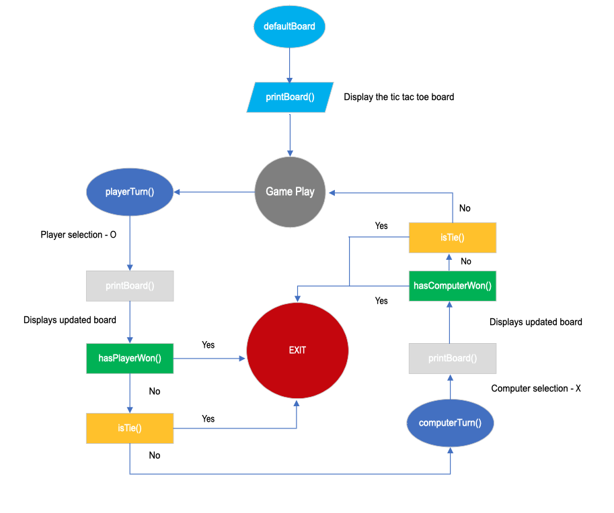

*Algorithms*



We have taken a fundamental approach to this project. The program has a main function and 6 user defined functions. These functions consist of syscalls, linear data structures and branches. No complex data structures or algorithms are used in this program. The tic tac toe table is an array. We used syscalls to display the game instructions and the table on the terminal as well as to get the player’s input. The player 1 input is from the console and player 2 is through generating random numbers from 0 – 9. We have implemented branches to check for duplicate moves and the result.

Computers Turn: First we seeded the random number generator with the systems current time. Then we generated a random number 0 – 9. This number was then converted to an offset for the array. If the spot in the array was already greater than 9, that means that someone had already played in the spot and another number was generated until a suitable spot was found.

Printing Board: To print the board a simple loop was used to print the array element and a bar. Every 3 iterations it would print a new line and a horizontal bar allowing the output to look like it was a tic-tac-toe board.

Checking for a win: This was completed by loading the 3 values for whatever spaces were being checked and then the values were compared. If the values were not equal then the program would branch to the next row, column or diagonal and check until every possible win had been checked. This was repeated checking if the values were the same as the players or the computers and the appropriate output would be displayed based on the winner.



Francis Allen:

Helped with making the making the part of the program that checked the winner and also with fixing any bugs that the program had.

Jesse Aaron Jones:

Helped with making the printing part of the tic-tac-toe game and helped with the updating part of the program. Jesse also helped print out the table.

Rohit Raju:

Helped by making most of the report and helped by creating some of the gameplay part of the code.

*Peer Review Page*

Tushar Wani:

Helped with figuring out the winner of the program. Tushar was able to implement code that was able to figure out the winner of the game.

Farman Ali

Helped me with making the computer’s turn algorithm and making the video for demonstrating the program.